 ETHORITY  AI BUSINESS OPERATING SYSTEM | The Good AI PRISM  by STEN & ETHORITY

Call-for-papers kit · Sten Franke
Founder & CEO · Chief AI Architect
Leads ETHORITY’s strategy, research and development of AI systems. Creator of the Social Media Prisma and Good AI Prism.
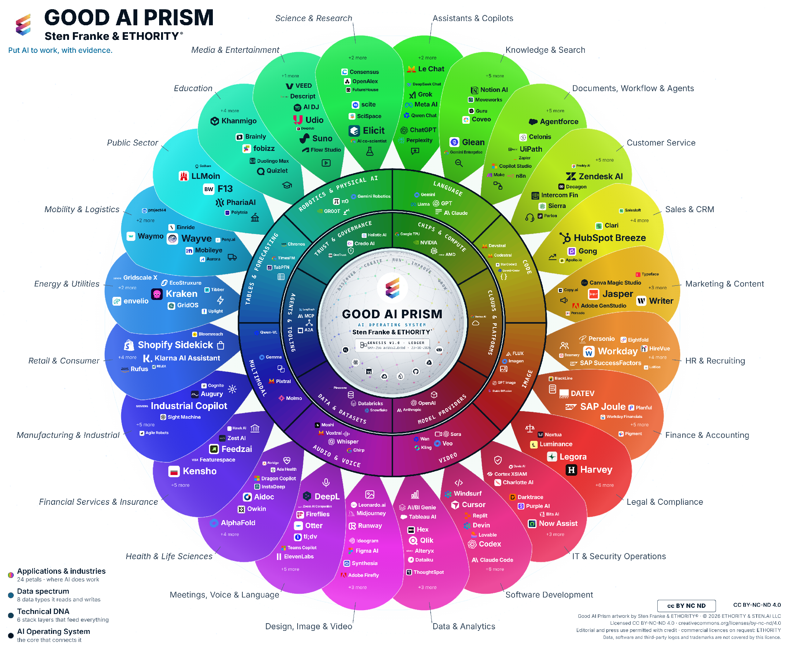
The Good AI Prism connects market exploration with dated source profiles and comparisons. Customer-specific selection, implementation and ongoing operation require an agreed scope.
Prism artwork v3.11 · selection snapshot 17 October 2026; study evidence cutoff 20 October 2026.

Titles
- Put AI to work: the decisions that will shape 2027
- From AI use to AI results: what the evidence says
- Which AI, how safely, and does it pay?
- The Good AI Prism: mapping the AI market for decision-makers

Short abstract (≈80 words)
AI adoption is advancing unevenly; few organisations can show what it delivers. Drawing on the Good AI Prism Market Study 2026/27, with evidence from more than 30 economies and a sourced map of 961 AI offerings, Sten Franke shows where adoption really stands, why know-how, rules and documentation slow it down, and how leaders can decide with evidence: a measured baseline, a supported pilot and two clear gates on the way to scale.

Long abstract (≈200 words)
AI adoption is advancing unevenly, and few organisations can show what it delivers. In a global survey, about nine in ten surveyed organisations report regular AI use and 37% attribute any EBIT effect to it; statistics offices count one EU firm in five with ten or more staff using AI. Drawing on the Good AI Prism Market Study 2026/27, which combines public market and buyer research from more than 30 economies with a sourced map of 961 AI offerings in the selected study edition, Sten Franke explains where adoption really stands and why it stalls: know-how is the barrier named most often, rules arrive as concrete dates by jurisdiction, and providers rarely publish the facts buyers need to compare offerings. The talk then turns evidence into decisions: six choices leaders face, each with a risk of moving too fast and too slowly; cost per accepted outcome as one measure that makes AI options comparable; and an agenda for 2027 with three phases and two gates, from a measured baseline to a supported pilot and evidence-based scale. Participants leave with next steps for their type of organisation and access to the study, the worksheets and the large-format Prism.

Learning objectives
- Read AI adoption figures correctly: separate firm statistics, surveys of large firms and usage telemetry.
- Apply cost per accepted outcome and a written pilot charter to one AI decision.
- Plan the 2027 agenda with two gates: a measured baseline before any pilot, an agreed threshold before any scale-up.

Short biography
Sten Franke is Founder & CEO · Chief AI Architect at ETHORITY. Leads ETHORITY’s strategy, research and development of AI systems. Creator of the Social Media Prisma and Good AI Prism.

Biography
Sten Franke is Founder & CEO · Chief AI Architect at ETHORITY. Leads ETHORITY’s strategy, research and development of AI systems. Creator of the Social Media Prisma and Good AI Prism. The current review connects a three-ring market map with profiles, sourced conditions, comparisons and seven calculator Pilots. The market studies and the live website describe different populations. The AI Business Operating System is a development direction; the public Workspace shows a demonstration. Potential capacity savings become realised financial value only when the corresponding operational change is demonstrated. His background connects industrial robotics, mediatime, Gridpatrol and ethority’s social-media intelligence work. A BVDW release dated 23 September 2009 names him as a Social Media working-group lead and a contributing author of the first Social Media Kompass. These are historical achievements, not current appointments or endorsements.

Selected public record
- NEXT Conference organiser profile
- Listed speaker, Chance Web 2.0 (2006)
- Former BVDW Social Media working-group lead; co-author, Social Media Kompass (2009)

Target audiences
- Executive boards and managing directors
- CIOs, CDOs and heads of digital transformation
- Owners and managers of mid-sized companies
- Procurement, legal, compliance and works councils
- Public sector, science and education leaders
- AI providers and their partners

Formats and languages
Keynote 20–30 min · deep-dive 45–60 min · workshop 90 min · panel or fireside 30–45 min · company event 30–90 min. English or German.
sten@ethority.ai · severin@ethority.ai · Study v2.2 · CFP v3.4 · 26 Oct 2026 · EN
Good AI Prism artwork © 2026 ETHORITY & STEN.AI LLC, by Sten Franke & ETHORITY®. CC BY-NC-ND 4.0; unchanged editorial/press use with credit also permitted. Data, software and third-party marks are outside this artwork licence.
Study v2.2 · CFP v3.4 · 26 Oct 2026 · EN

