 ETHORITY  AI BUSINESS OPERATING SYSTEM | The Good AI PRISM  by STEN & ETHORITY

Call-for-papers kit · Sten Franke
Founder & CEO · Chief AI Architect
Sten Franke brings entrepreneurial experience, market intelligence and systems architecture to the stage. His talks help audiences understand the AI market, choose useful applications and turn ambition into practical business decisions.
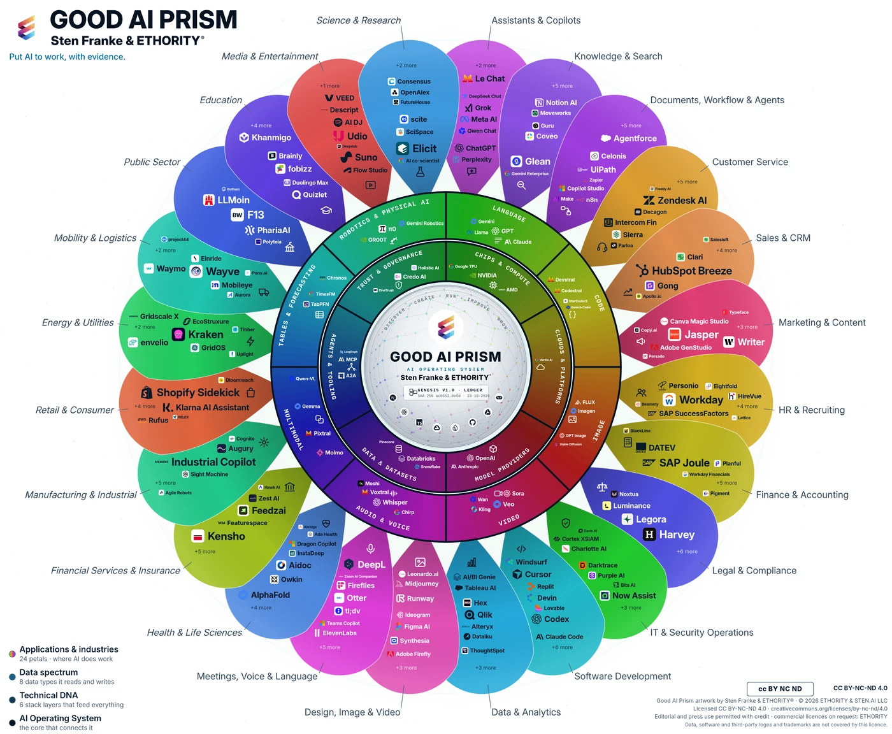
The Good AI Prism connects market exploration with dated source profiles and comparisons. Customer-specific selection, implementation and ongoing operation require an agreed scope.
Good AI Prism artwork v3.12 · study v2.6. Research windows and populations are stated in the referenced study.

Titles
- Put AI to work: the decisions that will shape 2027
- From AI use to AI results: what the evidence says
- Which AI, how safely, and does it pay?
- The Good AI Prism: mapping the AI market for decision-makers

Short abstract (≈80 words)
AI adoption is advancing unevenly; few organisations can show what it delivers. Drawing on the Good AI Prism Market Study 2026/27, with evidence from more than 30 economies and a sourced map of 961 AI offerings, Sten Franke shows where adoption really stands, why know-how, rules and documentation slow it down, and how leaders can decide with evidence: a measured baseline, a supported pilot and two clear gates on the way to scale.

Long abstract (≈200 words)
AI adoption is advancing unevenly, and few organisations can show what it delivers. In a global survey, about nine in ten surveyed organisations report regular AI use and 37% attribute any EBIT effect to it; statistics offices count one EU firm in five with ten or more staff using AI. Drawing on the Good AI Prism Market Study 2026/27, which combines public market and buyer research from more than 30 economies with a sourced map of 961 AI offerings in the selected study edition, Sten Franke explains where adoption really stands and why it stalls: know-how is the barrier named most often, rules arrive as concrete dates by jurisdiction, and providers rarely publish the facts buyers need to compare offerings. The talk then turns evidence into decisions: six choices leaders face, each with a risk of moving too fast and too slowly; cost per accepted outcome as one measure that makes AI options comparable; and an agenda for 2027 with three phases and two gates, from a measured baseline to a supported pilot and evidence-based scale. Participants leave with next steps for their type of organisation and access to the study, the worksheets and the large-format Prism.

Learning objectives
- Read AI adoption figures correctly: separate firm statistics, surveys of large firms and usage telemetry.
- Apply cost per accepted outcome and a written pilot charter to one AI decision.
- Plan the 2027 agenda with two gates: a measured baseline before any pilot, an agreed threshold before any scale-up.

Short biography
Sten Franke is a speaker, entrepreneur and the Founder & CEO and Chief AI Architect of ETHORITY. Creator of the Social Media Prisma and the Good AI Prism, he makes complex technology markets understandable. His talks connect AI with the decisions businesses face: where to invest, what to build and how to put it to work responsibly.

Biography
Sten Franke is a speaker, entrepreneur and the Founder & CEO and Chief AI Architect of ETHORITY. He has spoken at BITKOM conferences, NEXT Conference and online marketing conferences, bringing a practical perspective on how technology changes businesses and markets.
Creator of the Social Media Prisma and the Good AI Prism, he combines market intelligence, systems architecture and economic evaluation. His professional experience spans search technology, internet monitoring, social media intelligence and AI, with client projects for national and international brands.
On stage, Sten makes complex developments accessible and connects them to concrete decisions: which applications matter, where investment makes sense and what responsible implementation requires. He speaks in English and German, using visual maps and practical examples to help audiences find their way through the AI market.

Speaking experience
- BITKOM conferences · NEXT Conference · Online marketing conferences

Company references
- BMW Financial Services · Deutsche Telekom · T-Mobile · Disney · Lufthansa · Kraft Foods

Moderator introduction
Our speaker is Sten Franke, Founder & CEO and Chief AI Architect of ETHORITY, and creator of the Social Media Prisma and the Good AI Prism. He connects experience in technology and market intelligence with a practical question: how can AI work for your business? Please welcome Sten Franke.

Target audiences
- Executive boards and managing directors
- CIOs, CDOs and heads of digital transformation
- Owners and managers of mid-sized companies
- Procurement, legal, compliance and works councils
- Public sector, science and education leaders
- AI providers and their partners

Formats and languages
Keynote 20–30 min · deep-dive 45–60 min · workshop 90 min · panel or fireside 30–45 min · company event 30–90 min. English or German.
sten@ethority.ai · Study v2.6 · CFP v3.5 · 29 Oct 2026 · EN
Good AI Prism artwork © 2026 ETHORITY & STEN.AI LLC, by Sten Franke & ETHORITY®. CC BY-NC-ND 4.0; unchanged editorial/press use with credit also permitted. Data, software and third-party marks are outside this artwork licence.
Study v2.6 · CFP v3.5 · 29 Oct 2026 · EN

