 ETHORITY  AI BUSINESS OPERATING SYSTEM | The Good AI PRISM  by STEN & ETHORITY

PRESS RELEASE
Pre-release review edition · 24 October 2026

AI adoption is advancing unevenly. Few organisations can show what it delivers.
The Good AI Prism Market Study 2026/27 combines evidence from more than 30 economies with a sourced map of 961 AI offerings, and shows leaders how to decide with evidence before they scale.
San Francisco / Hamburg – AI adoption is advancing unevenly. In a global survey, about nine in ten organisations report regular AI use in at least one function; 44% report scaling it across the enterprise, and 37% attribute any EBIT effect to AI (McKinsey, Aug 2026). Official statistics are soberer: in the EU, one firm in five with ten or more staff uses AI (Eurostat 2025). These are different measures, and the study keeps them apart.
The pre-release study by ETHORITY, "Put AI to Work: The Good AI Prism Market Study 2026/27" reads public market and buyer research from 2025 and 2026 together with the Good AI Prism, a sourced map of the AI market with 998 market entries, including 961 AI offerings, across 24 business areas, 8 data types and 6 technology layers. Each entry is recorded with a dated source from the provider’s own pages.
The Good AI Prism is the AI-era successor to the Social Media Prisma, which Sten Franke created to map a fragmented digital ecosystem. It applies the same idea to AI: make a fast-moving market visible, so that organisations can see the options, the evidence behind them and what is still unknown before they decide.
“An AI decision should say what we expect to improve, what evidence supports the choice and who is accountable for the result. That is where putting AI to work begins,” says Sten Franke, Founder, Principal Architect & Lead Creator of ETHORITY.
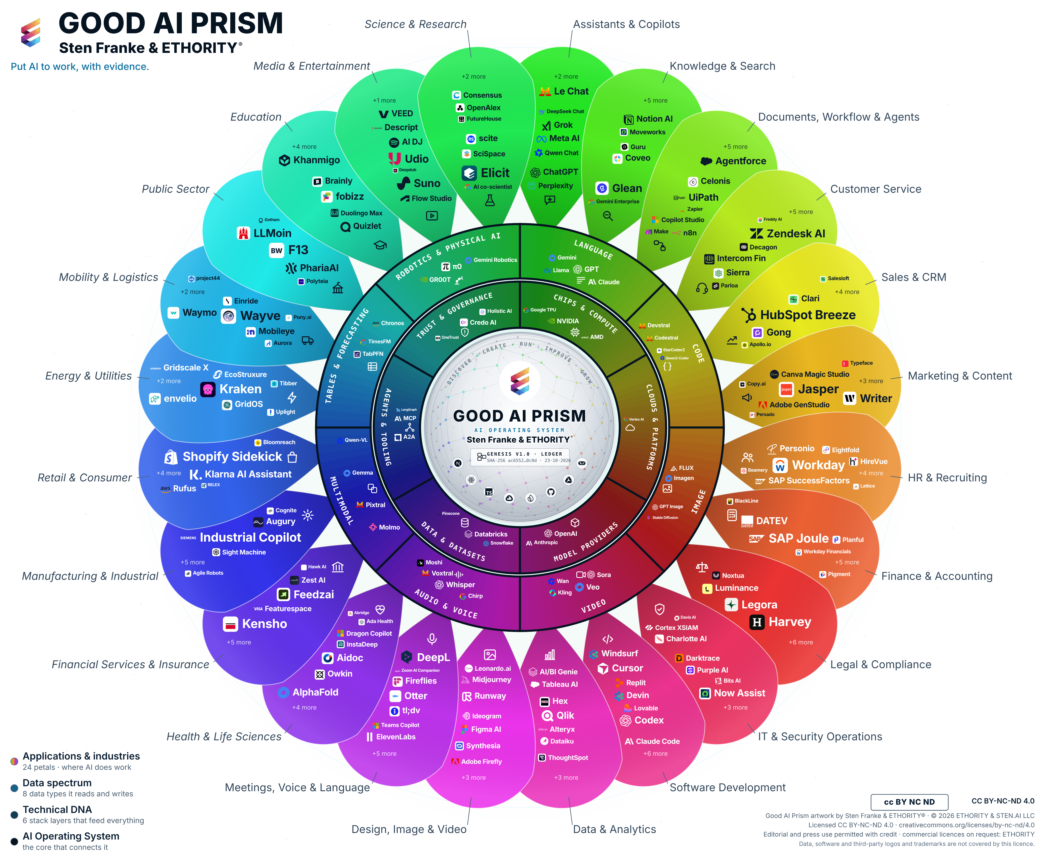
The Good AI Prism is ETHORITY’s visual entry point into the AI ecosystem—connecting market intelligence with selection, implementation and the development of its Marketplace.
Prism artwork v3.11 · selection snapshot 17 October 2026; study evidence cutoff 20 October 2026.
The study finds that large firms adopt AI 1.6 to 4.3 times as often as small ones in every national study compared, and that know-how is the barrier named most often: 71% of EU firms that considered AI name lack of expertise. EU AI Act: Annex III high-risk uses from 2 December 2027; Annex I product-related systems from 2 August 2028.
Buyers can rarely compare offerings on facts. 10 of 107 customer-service AI offerings document both an EU hosting option and limits on training with customer data (8 state no training; 2 train only with opt-in). Wave 1; provider information reviewed 19–20 Oct 2026. Prices for customer-service AI come in at least seven different billing units.
The study turns this evidence into an agenda for 2027 with three phases and two gates: a measured baseline before any pilot, a supported pilot under a written charter, and scale only where the agreed result on accepted outcomes is met. It includes practical worksheets and next steps for founders, the Mittelstand, large enterprises, the public sector, boards and AI providers.
AI-assisted research, system design and practical business work. Named people remain accountable for evidence, decisions and delivery. The Good AI Prism connects sourced market orientation with profiles and business questions.
ETHORITY connects market intelligence, research and scoped service work. Its public Workspace demonstrates the intended relationships between research, decisions, projects and an organisation’s AI estate.

Key figures
- 30+ economies compared
- 998 market entries, including 961 AI offerings, each with a dated provider source
- 194 depth-research records in Customer Service and Manufacturing
- Editions: Global (42 pages) and Germany & United States Focus (34 pages), each in English and German

About the study
The study is Wave 1 of ETHORITY’s longitudinal research programme, which observes the same provider sources repeatedly: in each wave ETHORITY reads the providers’ own pages, records what they document with source and date, and compares the result with the previous wave. The market and buyer figures are a separate synthesis of external studies from 2025 and 2026 (official statistics, associations, academic studies and consulting surveys), each cited with its own source, sample and method and not pooled. Wave 1 documents the state of the provider information ETHORITY reviewed on 19–20 October 2026. Changes are recorded in subsequent waves. Providers can submit corrections at the study page; confirmed corrections are recorded, dated, in the following wave. Cite as: ETHORITY (2026), Put AI to Work: The Good AI Prism Market Study 2026/27.

About ETHORITY
ETHORITY connects AI market intelligence, research and practical delivery so organisations can decide where AI belongs and put it to work with evidence, clear responsibility and measurable results. The AI Business Operating System is its architectural direction; the public Workspace is a demonstration. ETHORITY & STEN.AI LLC was formed in 2023; its historical ethority chapter began in 2005.

About Sten Franke
Sten Franke builds the systems that turn emerging technology into business capability. A digital pioneer and entrepreneur since 1997, he founded mediatime, Gridpatrol and ETHORITY, created the Social Media Prisma, and now leads the vision, architecture and development of the Good AI Prism and ETHORITY’s AI Business Operating System. His background combines industrial robotics, enterprise market intelligence and hands-on AI engineering.

Media contact
Sten Franke · sten@ethority.ai
Severin L. Wilson · severin@ethority.ai
Study v1.10 · EN: https://index.ethority.ai/review/good-ai-prism-v3-11-20261023/ai-prism-study
Good AI Prism artwork © 2026 ETHORITY & STEN.AI LLC, by Sten Franke & ETHORITY®. CC BY-NC-ND 4.0; unchanged editorial/press use with credit also permitted. Data, software and third-party marks are outside this artwork licence.
Study v1.10 · EN

