 ETHORITY  AI BUSINESS OPERATING SYSTEM | The Good AI PRISM  by STEN & ETHORITY

Call-for-papers kit · Sten Franke
Founder, Principal Architect & Lead Creator
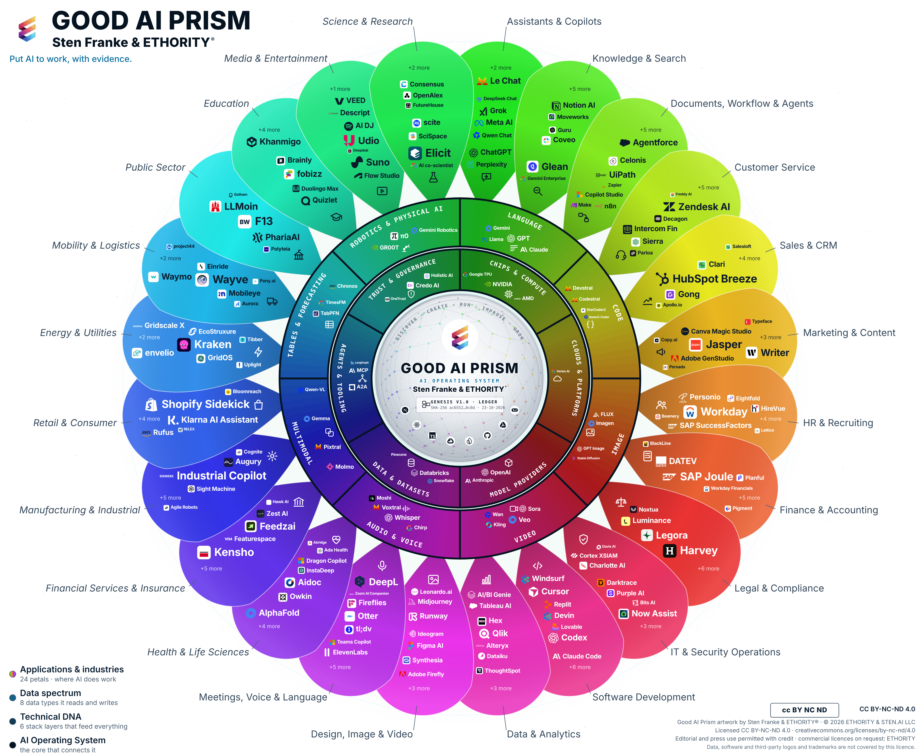
The Good AI Prism is ETHORITY’s visual entry point into the AI ecosystem—connecting market intelligence with selection, implementation and the development of its Marketplace.
Prism artwork v3.11 · selection snapshot 17 October 2026; study evidence cutoff 20 October 2026.

Titles
- Put AI to work: the decisions that will shape 2027
- From AI use to AI results: what the evidence says
- Which AI, how safely, and does it pay?
- The Good AI Prism: mapping the AI market for decision-makers

Short abstract (≈80 words)
AI adoption is advancing unevenly; few organisations can show what it delivers. Drawing on the Good AI Prism Market Study 2026/27, with evidence from more than 30 economies and a sourced map of 961 AI offerings, Sten Franke shows where adoption really stands, why know-how, rules and documentation slow it down, and how leaders can decide with evidence: a measured baseline, a supported pilot and two clear gates on the way to scale.

Long abstract (≈200 words)
AI adoption is advancing unevenly, and few organisations can show what it delivers. In a global survey, about nine in ten surveyed organisations report regular AI use and 37% attribute any EBIT effect to it; statistics offices count one EU firm in five with ten or more staff using AI. Drawing on the Good AI Prism Market Study 2026/27, which combines public market and buyer research from more than 30 economies with a sourced map of 998 market entries, including 961 AI offerings, Sten Franke explains where adoption really stands and why it stalls: know-how is the barrier named most often, rules arrive as concrete dates by jurisdiction, and providers rarely publish the facts buyers need to compare offerings. The talk then turns evidence into decisions: six choices leaders face, each with a risk of moving too fast and too slowly; cost per accepted outcome as one measure that makes AI options comparable; and an agenda for 2027 with three phases and two gates, from a measured baseline to a supported pilot and evidence-based scale. Participants leave with next steps for their type of organisation and access to the study, the worksheets and the large-format Prism.

Learning objectives
- Read AI adoption figures correctly: separate firm statistics, surveys of large firms and usage telemetry.
- Apply cost per accepted outcome and a written pilot charter to one AI decision.
- Plan the 2027 agenda with two gates: a measured baseline before any pilot, an agreed threshold before any scale-up.

Short biography
Sten Franke is a digital pioneer, entrepreneur and AI systems architect. Since 1997 he has built mediatime, Gridpatrol and ETHORITY, created the Social Media Prisma, and now leads the vision, architecture and development of the Good AI Prism and ETHORITY’s AI Business Operating System.

Biography
Sten Franke builds the systems that turn emerging technology into business capability. A digital pioneer and entrepreneur since 1997, he founded mediatime, Gridpatrol and ETHORITY, created the Social Media Prisma, and now leads the vision, architecture and development of the Good AI Prism and ETHORITY’s AI Business Operating System. His background combines industrial robotics, enterprise market intelligence and hands-on AI engineering.

Selected public record
- NEXT Conference organiser profile
- Listed speaker, Chance Web 2.0 (2006)
- Former BVDW Social Media working-group lead; co-author, Social Media Kompass (2009)

Target audiences
- Executive boards and managing directors
- CIOs, CDOs and heads of digital transformation
- Mittelstand owners and managers
- Procurement, legal, compliance and works councils
- Public sector, science and education leaders
- AI providers and their partners

Formats and languages
Keynote 20–30 min · deep-dive 45–60 min · workshop 90 min · panel or fireside 30–45 min · company event 30–90 min. English or German.
sten@ethority.ai · severin@ethority.ai · Study v1.10 · EN
Good AI Prism artwork © 2026 ETHORITY & STEN.AI LLC, by Sten Franke & ETHORITY®. CC BY-NC-ND 4.0; unchanged editorial/press use with credit also permitted. Data, software and third-party marks are outside this artwork licence.
Study v1.10 · EN

